1. Find the contact (or “person”) record for your donation.
→If there is more than 1, deduplicate the records.
→If there is not a record for your contact, create one.

2. Check & update pledges for your contact.
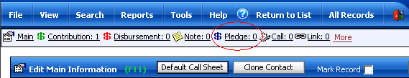

3. Add a contribution record to your contact.

4. Enter and double-check the date & amount for the contribution.
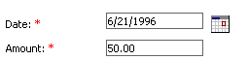
→If the Accounting department has difficulty processing your check, the date may be altered to make the FEC report accurate.

5. Fill in the source code for the check that you are processing.
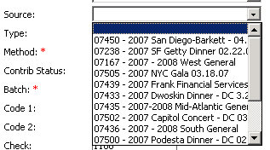
→If you are unsure of what source code is needed, or if one has to be created, ask Beth to help you.

6. Assign the check to the default batch number 0.

7. Assign the proper account code to the check.
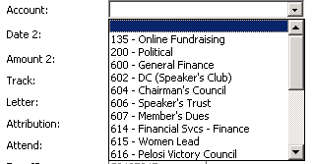
→If you are unsure of what account code to use, ask Beth.

8. Assign any “External Fundraiser” credit to the check through the “Attribution” box.

9. Assign Member Credit to the check through the “Tally Member” system.
→If you are unsure of what Member to credit the check to, ask the Regional Director.

10. Assign regional credit to the check through the Tally Member system.

11. Save the contribution record & generate a transmittal form.

